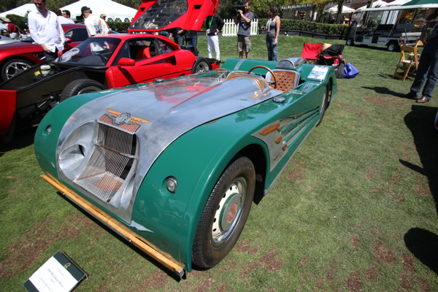

1960 MGA with special "Savoy" body -- The question here is, naturally, what the hell? Someone stripped off the lovely bodywork by Syd Enever and installed sheet allow and wood that looks like it was designed in reform school shop class? There's sawtooth fins and walnut body pieces and carpet that looks like astroturf and a grille with high-tension wire that looks like a very large cheese slicer. And the atrocious shade of green looks like the rest room in some awful pro shop.

